Lab Test-1

Task-1:

#Write a python function that checks whether a string is a palindrome

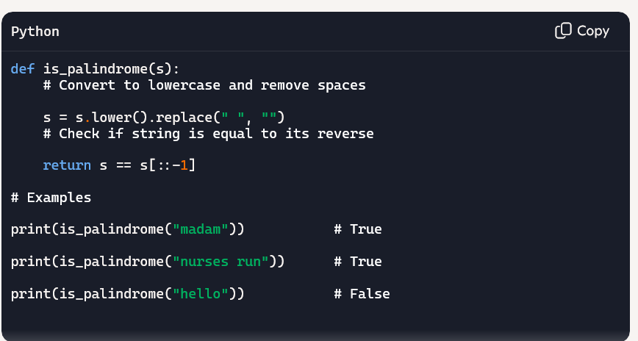

Explaination:

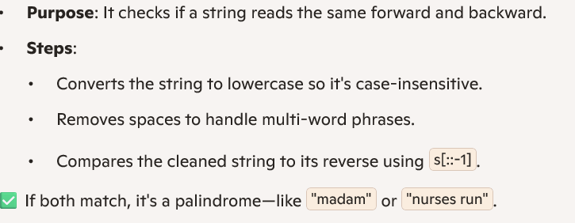

Task-2

#To generate a python programme that finds the largest and smallest numbers in a user provided list.

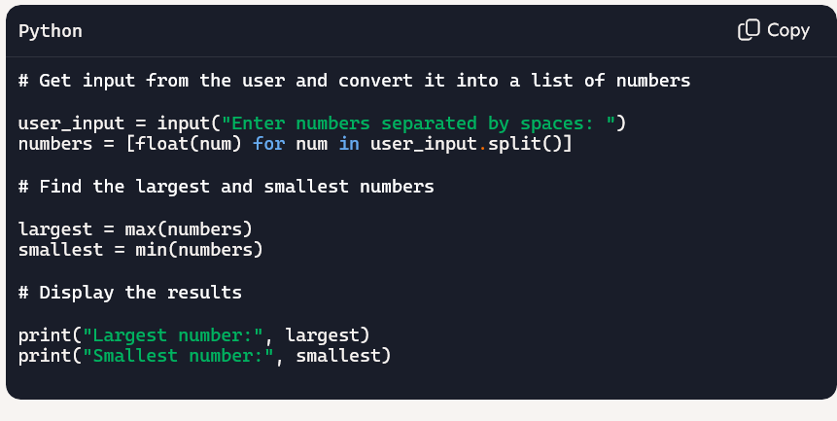

Output:

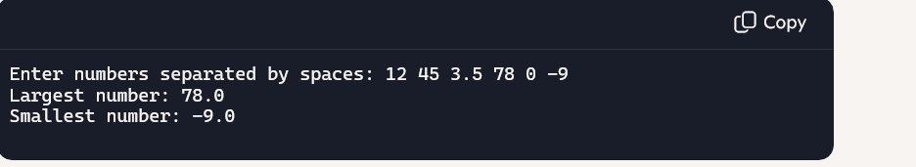

Explaination:

